Capturing DRA In Unify Performance Matters

You can easily capture DRA scores within the Unify platform for display in BBCard. However, because Unify is intended generally for more traditional-type assessment, there is a little work to do to put it in an easy-to-use display for teachers.

Fundamentally, the process involves 4 steps:
- Create a shell assessment in Unify for teacher entry of DRA observational scores. (This can be shared with you from within Unify.)
- Release the assessment to students for whom DRA will administered, and teachers will select the appropriate responses and scores from within Online Scoring in the platform.
- At the end of the DRA window, export all DRA results from SIA and convert them to the text that should be displayed on the screen in BBCard. (We can support you with the first one of these.)
- Create a ticket at help.powerschool.com to have the data uploaded into BBCard. If you would like color-banding applied to these data, then supply the cut scores for each color band as well as the grade level to which each applies.

The test structure is simply four or more items (depending on what elements of the DRA you would like to capture). Then, each item is scored in online scoring, where a code for each response is captured for later conversion (for example, 1 = instructional, 0 = independent). A screen of Online Scoring is shown below.
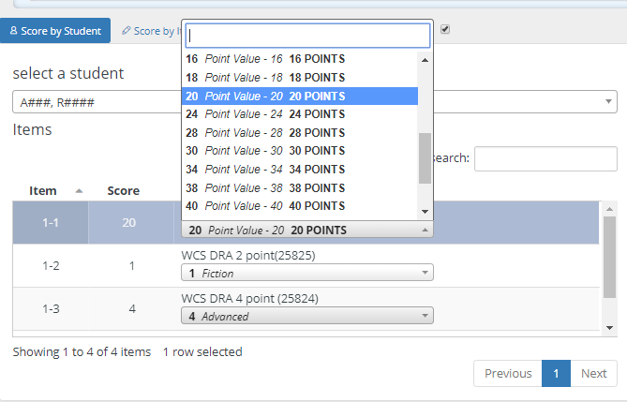

Note that all the teacher will do is select the response that corresponds to the appropriate observation or score for each item.
Once the window closes, the scores are exported via .csv format into an Excel spreadsheet, where each code value is quickly converted via “Find and Replace” to the appropriate text as it should read in BBCard.

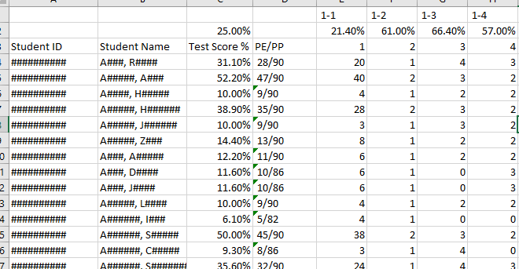

For example, in this extract, all 2s in Column 4 were converted to “Instructional,” and other codes were changed to their corresponding values for display.

Finally, the file is modified to fit into our “Nested” file layout, which is shown for reference. We will provide the file layout in Excel format. As you can see, each student has a number of row entries equal to the number of items you would like to import into BBCard, and the column preceding scores and the score column are the only columns that needs to be changed for each student other than their IDs. Of course, this is easily done in a pivot table using Excel.

A couple of notes:
- During the administration, you might want to hide the scores in BBCard from teachers, as they will present as percentages. This, again, is because the platform is designed for traditional testing. Of course, the scores are always available in SIA, so training around this is necessary.
- Subsequent submissions (winter, fall, etc.) will be identical in all respects! Do not change anything except the date column and the students’ scores. The title of the “tests” creates folders and the date puts them as new instances. If you change the tests title, then a new folder will be created rather than scores being entered into the existing folder.

